AAPA Communications Award Program Entry Classification: Overall Campaign

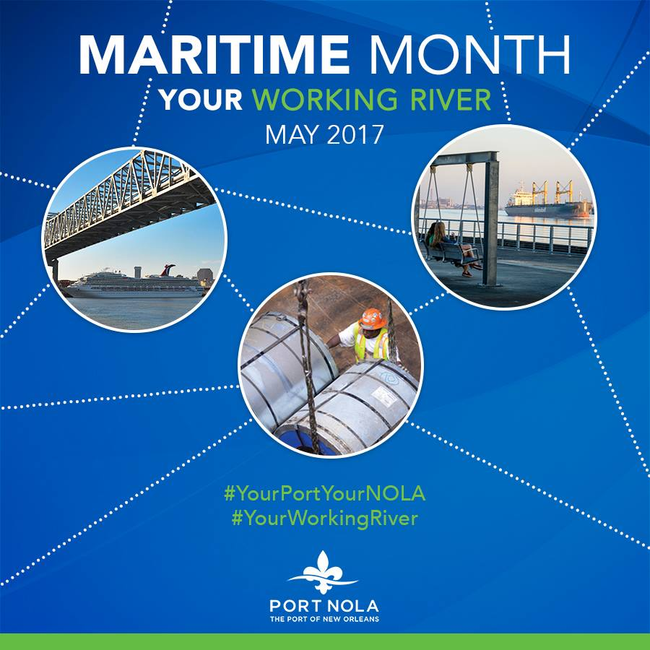
Summary - Port NOLA Maritime Month and Maritime Day Campaign 2017
The Port of New Orleans celebrated Maritime Month throughout May and National Maritime Day May 22, recognizing the value of maritime commerce in the region and paying tribute to the region’s rich maritime history, through an integrated, multi-channel outreach campaign.

1. What are/were the entry’s specific communications challenges or opportunities?
The Port of New Orleans is a major economic engine in the city and state, yet the general public does not immediately equate jobs and the economy with the Port. We also have a physical barrier: a miles-long flood wall that separates much of the riverfront cargo and cruise activity from the neighboring residences and businesses. Leaving people to wonder: what goes on beyond the flood wall?
In the past, we had observed May 22 National Maritime Day with social media posts and the occasional op-ed. In 2017 the Port NOLA Public Affairs team wanted to seize the opportunity to extend that Maritime Day message throughout the month of May to raise public awareness about the value of the Port and our importance to the community – through a variety of events, partnerships, promotions, website and social media channels.
We had a short timeline – just over two weeks – to plan and launch this campaign, we had a small amount of funding left in our budget which was designated specifically for advertising use.

2. How does the communication used in this entry complement the organization’s overall mission?
The Port of New Orleans mission is: To drive regional economic prosperity by maximizing the flow of international trade and commerce as a modern Gateway.
If the community sees the Port as an economic engine, they are more likely to become ambassadors for our mission and support the Port when issues arise such as the funding of capital improvements or land use issues for potential port development.
3. What were the communications planning and programming components used for this entry?
Objectives:
- Celebrate the hardworking men and women who make New Orleans’ maritime industry a success and educate the general public about the value the Port of New Orleans and maritime activity bring to the community.
- Observe National Maritime Day is May 22: decreed by Congress in 1933 as a day for the United States to observe its proud maritime heritage, honor those who serve and have served in maritime, and recognize the many benefits that result from America’s maritime industry.
- Leverage Maritime Month – May: Port NOLA joins several Ports across the country is celebrating and raising public awareness of the maritime industry. (continued)

Key messages:
- The Port and Maritime industry are a critical component of the Greater New Orleans region’s past, present and future success.
- Port NOLA activity helps generate jobs and millions of dollars in economic impact.
- The hardworking men and women of the Port and Port-related businesses are valued and are vital to the success of New Orleans and the region.

Audience:
- Primary: general public, non-maritime partners, and policy-makers
- Secondary: Port NOLA maritime stakeholders and tenants

4. What actions were taken and what communication outputs were employed in this entry?
We sought to leverage all the communications tools at our access and we developed a partnership with the No. 1 morning news show in the region, WWLTV Morning News. We did all the work in-house except for the advertising spots and news broadcast produced by our media partner WWLTV.

Timeframe: May 1 – 31, 2017
Concept: Your Working River – Port NOLA Maritime Month 2017

Tools - Earned/unpaid Communications:
- WWLTV Morning Show Broadcast Monday, May 22: lineup of speakers
- Talking Points for all May speaking engagements
- Press Releases
- Maritime Month graphic
- Stakeholder outreach emails
- Employee outreach emails
- Photos: stock and live shots to send to media per event
- The existing Community Outreach video
- Social Media graphics/memes for Facebook, Twitter, LinkedIn, Dedicated hashtags
- Website: breaking news item and splash page on portno.com
Tools - Paid:
- WWLTV :30 and :15 spots throughout the month
- WWLTV web banners, blogs/newsletter.

Actions:
- Website – A splash page was created at portno.com with an intro explaining maritime month/day, a list of events and links to watch the video, press release, link to WWLTV.com.
- WWLTV Paid–Throughout the month, the station ran banner ads on their website, ran :30 and :15 promo ad spots on TV, posted 2 New Orleans 100 newsletter blog entries (May 2 and 16), distributed information via social media, and pre-produced footage throughout the month to run during Maritime Day broadcast.
- WWLTV Morning Show News: Broadcast held 7-9 am Monday, May 22 on location at the Port NOLA admin building with a view of the river and bridge, with live remote on the Fireboat.
- Press Releases – one launched Maritime Month on May 1. One to announce Bike Patrols/Harbor Police Week.
- Constant Contact email distribution – One to launch Maritime Month distributed to the various stakeholder groups. One for each of any press releases. (continued)
- Social Media Plan – Maritime Month will be the subject of multiple posts on all social media channels Facebook, Twitter and LinkedIn. Main themes: Economic Impact, Cargo Connections, Cruise NOLA, Environmental Leadership. Posts will include branded Maritime Month memes, port fun facts, links, hashtags, live and pre-produced video, etc.
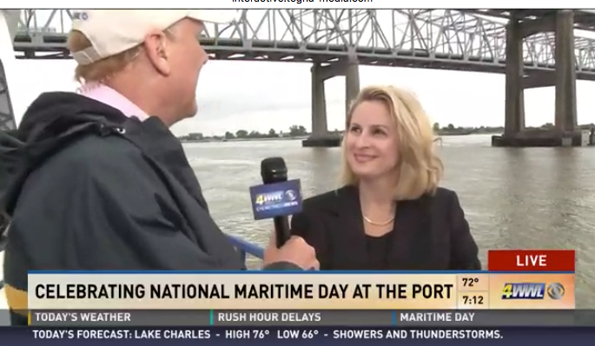
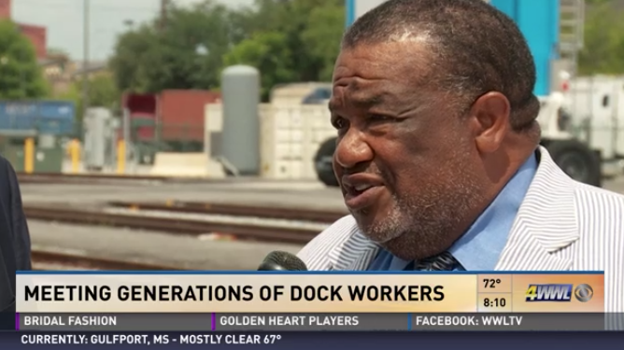

View the Videos here:
WWLTV Port NOLA Maritime Month 2017 Promo Spot
WWL-TV News Pieces from Maritime Day 2017
Interview with Longshoremen
Interview with President & CEO Brandy D. Christian
Interview with VP Commercial & Operations Bobby Landry
Second Interview with VP Commercial & Operations Bobby Landry
Cruise Interview with VP Public Affairs Michelle Ganon
Final Interview with VP Public Affairs Michelle Ganon

5. What were the communications outcomes from this entry and what evaluation methods were used to assess them?
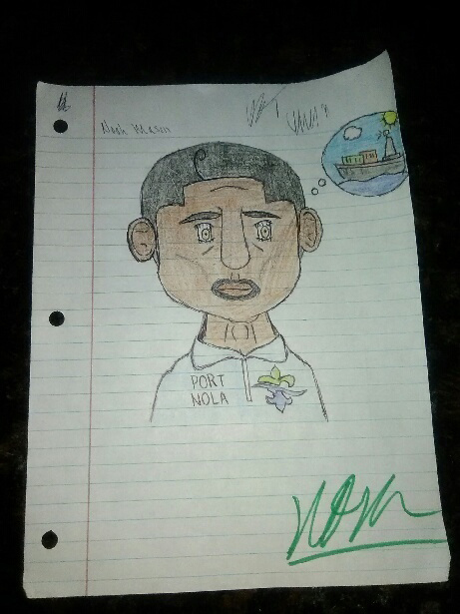
Anecdotal: The feedback was overwhelmingly positive across all our audiences and outreach channels. Our industry stakeholders were happy to participate and have asked be involved again. Members of the community were appreciative and enthusiastic about going “behind the flood wall” for the port tour. One of the high school students was so inspired by our Maritime Month Career Day that he went home and drew a self-portrait of himself wearing a Port T-shirt and sent it to us.
We plan to build on the success of this first-ever Port NOLA Maritime Month effort and based on these metrics and other positive audience feedback, not only will people start to see Port NOLA as a great asset to the community, they will also look forward to future Maritime Month engagement.

Measurables:
- WWLTV Partnership - paid ads
- 164 x :30 spots month-long
- M-Sun WWLTV.com 300,000 impressions desktop and mobile
- M-Sun WWLTV.com 125,000 in-banner videos
- 2x- Home Page Push Down on WWLTV.com
- 2 x New Orleans 100 Post (continued)
- WWLTV Partnership - News component
An average of 18,000 households tuned in during the 2-hour broadcast. Just as important, the content held the audience and grew it, proving that people were engaged and interested.
- Earned media: The 2017 Maritime Month campaign reached approximately 733,448 online news visitors with a total online news publicity value of $54,178.
- Facebook: Following the 2017 Maritime Month campaign, the Port NOLA Facebook page had 3,476 followers, again of 44 followers and had 3,678 page likes.

